HOW TO MAKE A SIMPLE KALEIDOSCOPE FOR KIDS

HOW TO MAKE A SIMPLE KALEIDOSCOPE FOR KIDS
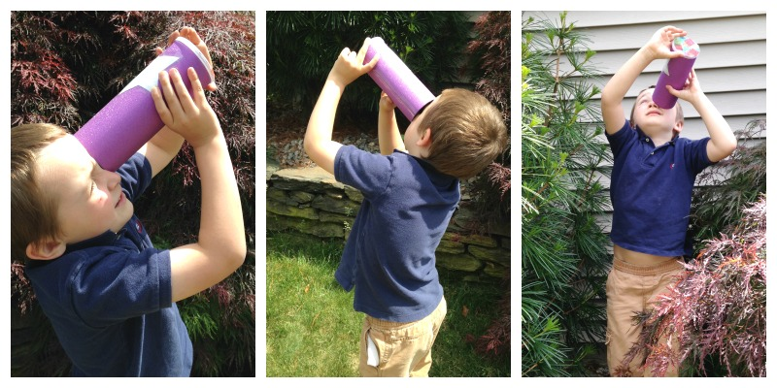
MATERIALS NEEDED FOR A SIMPLE KALEIDOSCOPE:
Pringles can {without chips}
Shimmery scrap-book paper or aluminum foil
Hammer and nail
Clear glue
Tissue paper, glitter, and sequins
Simple kaleidoscope science. Since we didn’t have a prism or mirrors for our kaleidoscope, our science lesson was pretty basic. We discussed the reflection of light. When the light comes in, it bounces off the shimmery paper and is reflected back out in the direction it came in. This creates the colors and patterns. He pointed out all the colors he could see as he twisted the lid.

EASY TO MAKE SIMPLE KALEIDOSCOPE
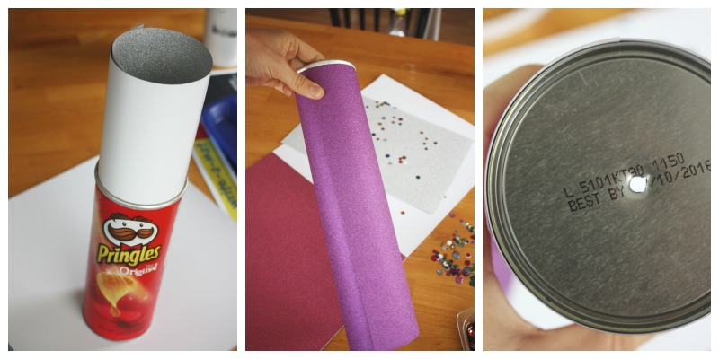
Get started on your simple kaleidoscope right away. Remove chips, rinse, and dry can! I rolled a piece of shimmery silver paper and put it inside can. Mark and cut off excess. I did not have to tack it down as it uncurled nicely inside the can. I covered the outside in a shimmery purple and secured with tape. Decorate if you like! Use a hammer and nail to punch an eye hole in the other end of the can.
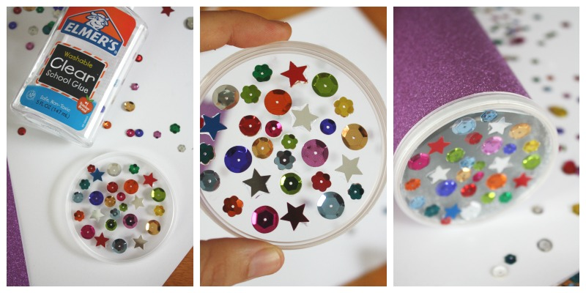
We added a step to our simple kaleidoscope by gluing sequins on the inside of the Pringle’s can lid.
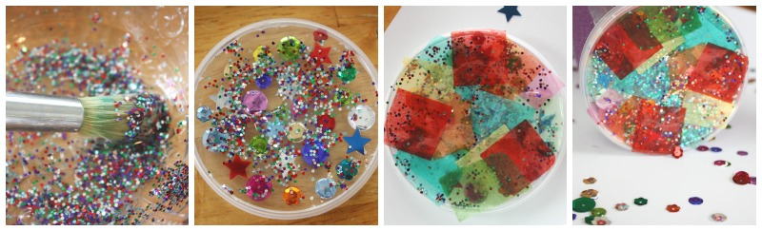
I mixed clear glue with a bit of water and glitter, lots of glitter. We tore and cut tissue paper to glued to the outside of the lid.
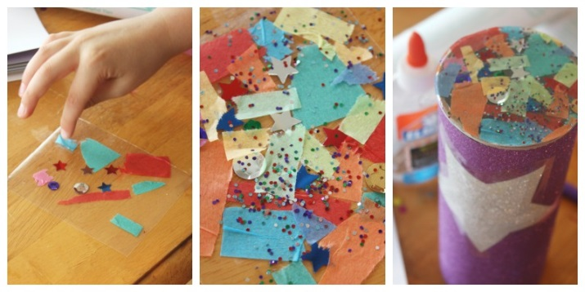
Your simple kaleidoscope needs one more thing. You need to make a second colourful lens. This time I used contact paper. I cut a square and taped it sticky side up to the table. He added a little bit of everything. I pressed another piece of contact paper over the top to seal it. Cut to fit can. You will be putting the lid on over this, so make sure it is a close fit. Glue to top of can. Very important to let everything dry really well. Put the lid on your simple kaleidoscope and head outside.

